**5 Case Study Application – Vibration Isolation Design**

The application of DCTO methodology is demonstrated on a vibration isolation design problem. Vibration isolation relies on the balance of inertia, damping, and stiffness properties where, in active vibration isolation, an additional active gain factor enhances the system’s damping behavior. To achieve the optimal vibration isolation outcome, the design engineer typically specifies the resonance and isolation frequencies and then balances mass, damping, stiffness, and the gain factor.

**5.1 Case Study Problem**

The experimental dynamical system studied herein is a one-mass oscillator subjected to passive and active vibration isolation (Figure 1). The system consists of a rigid rectangle frame, a rigid mass oscillator held by four identical orthogonally placed leaf springs, and a voice coil actuator (VCA).

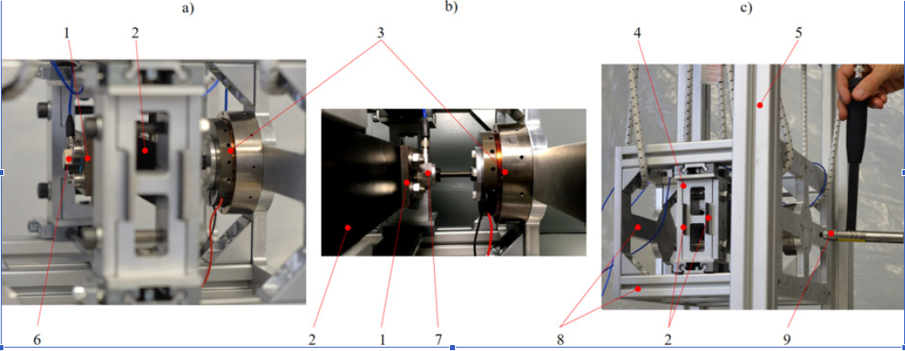

Figure 1: The physical test rig for the dynamic vibration system. Shown above, the test setup from diﬀerent views. Depicted here are the rigid mass (1), one leaf spring (2), VCA (3), fixed leaf spring support (4), mount (5) to suspend the frame (8), acceleration sensor Sa;z (6), force sensor SFVCA (7), rigid frame (8), and a modal hammer (9) with a force sensor SF to excite the frame. The sensor Sa;w to measure the acceleration of the frame is on the inner side of the frame near the location where the impulse hammer hits (hammer not visible in the figure).

In Figure 2a, a rigid mass *m* oscillates in the *z*-direction due to a base point excitation *w*(*t*). A damper with the damping coefficient *b* and a spring element with a stiffness constant *k* connect the mass to the base point. The damper and spring provide the system’s internal passive damping force, active damping force, and stiffness force

|  |  |
| --- | --- |
| $F_{b}=b[\dot{z}\left(t\right)-\dot{w}\left(t\right)]$, $F_{k}=k[z\left(t\right)-w\left(t\right)]$, $F_{a}=-g \dot{z}\left(t\right)$ | (1) |
|  |  |

with *F*a derived from a simple velocity feedback control with the gain factor *g*.

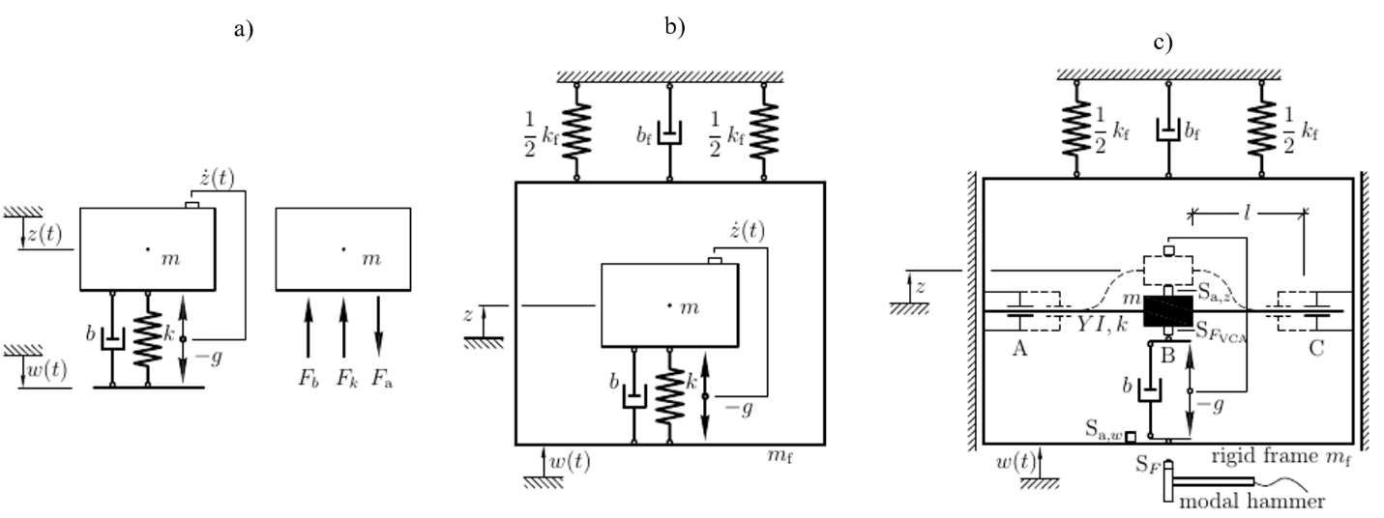

Figure 2: Schematic diagram of the test rig for the dynamic vibration system: (a) schematic representation of the one-mass oscillator, (b) one-mass oscillator with an additional frame as the base point, (c) schematic representation of the real test setup.

The inhomogeneous differential equation of motion of the one-mass oscillator in Figure 2a can be written as

$\ddot{z}\left(t\right)+\left[2D_{p}ω_{0}+\frac{g}{m}\right]\dot{z}\left(t\right)+{ω_{0}}^{2}z\left(t\right)=2D_{p}ω_{0}\dot{w}\left(t\right)+{ω_{0}}^{2}w\left(t\right)={ω_{0}}^{2}r\left(t\right)$ (2)

using the abbreviation

$2D_{p}ω_{0}=\frac{b}{m}$, and ${ω_{0}}^{2}=\frac{k}{m}$ (3)

including the damping ratio $D_{p}$ from passive damping, with 0 *< $D_{p}$ <* 1, as well as the angular eigenfrequency $ω_{0}$. The term ${ω_{0}}^{2}r(t)$ in (2) is the general expression for the excitation function, which, in this case, is the linear combination of damper and spring base point excitation $2D_{p}ω_{0}\dot{w}\left(t\right)+{ω_{0}}^{2}w\left(t\right)$.

Figure 2b depicts the representation of the laboratory set-up used in this study, in which a rigid frame with mass $m_{f}$ serves as a base point structure. The frame is fixed by a gliding support that is assumed to have no friction perpendicular to the *z*-direction. The frame is constrained by a damper with the damping coefficient $b_{f}$ and springs with a total stiffness $k_{f}$ in the *z*-direction.

In the laboratory application, the frame suspends from a rigid mount via elastic straps vertical to the *z*-direction, allowing the frame to move freely in the *z*-direction as shown in Figure 2c. The idealized damping $b_{f}$ and $k_{f}$ that constrain this movement are relatively small, compared to the *b* and $k$ of the mass. The frame moves in a translational *z*-direction because of a time-dependent translational excitation displacement *w*(*t*) in the *z*-direction. As shown in Figure 2c, the frame retains two supports that fix a leaf spring at its ends at A and C, with the effective  
bending length *l* on both sides A-B and B-C, with a rigid mass *m* in the center position at B.  
The leaf spring is the practical realization of the spring elements in Figure 2a and b. Its  
stiffness

|  |  |
| --- | --- |
| $k^{*}=12 EI/l^{3}$ | (4) |

is a function of the bending stiffness *EI*, where $E$ is the Young’s modulusof the leaf spring, $I$ is the geometrical moment of inertia, and $l$ is the length of the leaf spring. Two leaf springs are mounted in parallel with length *l* on each side of A-B and B-C (see Figure 2c). With four leaf springs, the total stiffness becomes *k* = 4*k\**. The two supports at A and C in Figure 2c are adjustable along *l* to tune the leaf spring’s bending deflection and therefore its effective stiffness *k*.

A voice coil actuator (VCA) realizes an electromotive force *F*VCA as the passive damping  
and the active force *Fb* and *Fa* (Figure 2c). The force sensor S*F*VCA at B in Figure 2c measures the sum of forces *Fb* and *Fa* acting on the moving mass. The acceleration sensors Sa*;z* and Sa*;w* measure directly the accelerations of mass and frame, $\ddot{z}$ and $\ddot{w}$. The accelerations are transformed  
into velocities $\dot{w}$ and $\dot{z}$ by numerical integration in the Simulink-dSpace environment. The  
masses of Sa*;z*, S*F*VCA and parts of the leaf spring are included in mass *m* (Table 1).

Figure 2c also shows a modal hammer with a force sensor S*F* to excite the frame. It creates  
the impulse force

|  |  |
| --- | --- |
| $$\hat{F}\left(t_{0}\right)=\int_{-∞}^{∞}{F\left(t\right)∙δ\left(t-t_{0}\right) dt, }$$ | (5) |

including the Dirac-impulse function *δ*(*t - t*0) that leads to the vibrational response of the  
frame

|  |  |
| --- | --- |
| $$w\left(t\right)=\frac{\hat{F}\left(t_{0}\right)}{m_{f} ω_{D,f}}∙e^{-D_{f} ω_{0,f} t }\sin{ω_{D,f}}t,$$ | (6) |

in the time domain, with the damping ratio *D*f, angular eigenfrequency $ω_{0,f}$ and the damped  
angular eigenfrequency $ω_{0,f}$ of the frame’s movement in *z*-direction. (6) is only valid for low damping 0 *< D*f *<* 1. This leads to the total vibration response

$z\left(t\right)=r_{0}\{1-e^{-Dω_{0}t}[cosω_{D}t-D\frac{ω_{0}}{ω_{D}}sinω_{D}t]\}$. (7)

The *particular solution $r_{0}$*  is part of the general excitation function ${ω_{0}}^{2}r(t)$ in (2), which takes the form of an excitation step function

$r\left(t\right)=r_{0} σ(t-t_{0})$ (8)

when multiplied with the unit step function *σ*(*t - t*0) as the integral of the Dirac-impulse  
function *δ*(*t - t*0) in (5). From the relation $2D_{p}\dot{ω_{0}}\dot{w}\left(t\right)+{ω_{0}}^{2}w\left(t\right)={ω_{0}}^{2}r\left(t\right)$ in (2),

$r_{0}=\frac{1}{ω_{0}}2D_{p}\dot{w_{0}}+w_{0}$ (9)

with the velocity *w*0 and displacement *w*0 at *t* = *t*0 that are derived from (6).

In this demonstration, the design problem is formulated with the gain factor *g* being the design parameter; the constant *k* for the four leaf springs is assumed to be poorly known and assigned as the calibration parameter, and the mass *m* of the system that need to be vibration isolated is treated as the control parameter. The control parameter varies within a predetermined range, the calibration parameter is tuned with respect to the experimental data, and the design parameter is sought during the design process for the optimal vibration isolation outcome.

Table 1. Geometrical, mass, and material values of each component in the vibration isolation test rig

|  |  |  |  |  |  |
| --- | --- | --- | --- | --- | --- |
|  | | | |  | |
| Category | Property | Variable | Value | | Unite |
| Rigid frame structure | sum mass | *m*f | 6.2073 | | kg |
| Vibrating rigid mass | sum mass, **min** | *m* | 0.7853 | | kg |
| 20x add. Weights, small | *mws* | 0.0760 | | kg |
| 24x add. Weights, large | *mwl* | 0.2880 | | kg |
| sum mass, **max** | *m* | 1.1493 | | kg |
| Geometry | leaf spring length, **min** | *l* | 4.00E-02 | | m |
| leaf spring length, **max** | *l* | 8.00E-02 | | m |
| leaf spring cross section, width | *d* | 4.00E-02 | | m |
| leaf spring cross section, height | *h* | 0.11E-02 | | m |
| Material | Young’s modulus (flexural) CFRP | *E* | 62.00E+09 | | N/m2 |
|  | stiffness CFRP, **min** | *k* | 25,788.1 | | N/m |
|  | stiffness CFRP, **max** | *k* | 206,305.0 | | N/m |
| VCA | force constant | *f* | 17.5 | | N/A |
|  | voltage amplification constant | *cv* | 1.5 | | - |
|  | passive damping coefficient, **min** | *b* | 16 | | Ns/m |
|  | passive damping coefficient, **max** | *b* | 130 | | Ns/m |
|  | passive damping ratio, **min** | *d* | 0.055 | | - |
|  | passive damping ratio, **max** | *d* | 0.46 | | - |
|  | active gain factor, **min** | *g* | 12 | | Ns/m |
|  | active gain factor, **max** | *g* | 90 | | Ns/m |

**5.2 Experimental Observations**

For the dual model calibration, 12 operational conditions for the test rig are designed for varying values of the mass *m* and gain factor *g* (shown in Table 2). To excite the test rig, an impulse force is applied in the translational *z*-direction via a modal hammer. The time history response of the hammer excitation is shown in Figure 3. Figure 4 shows the vibration response of the mass, as measured by the acceleration sensor Sa,z. Since the rigid frame is constrained by a spring of small stiffness in the *z*-direction, the resulting relatively low resonance frequency of the frame (~1.5 Hz) does not significantly affect the mass vibration with its higher eigenfrequency (> 20 Hz) when vibrating in the *z*-direction. The hammer impact is repeated 5 times, and the impact force and the system response measurements are are averaged.

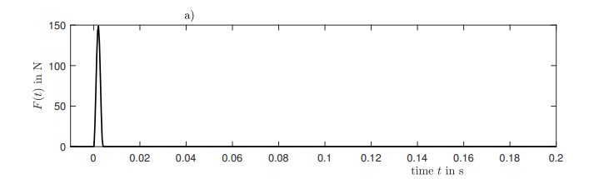

Figure 3: Schematic diagram of the applied impulse force in the time domain.

Figure 4: Five-times averaged acceleration response of the rigid mass in the time domain.

One significant character of an oscillatory system is its damping (i.e. how rapidly a vibration system will decay after the initial excitation). The damping ratio, a dimensionless measure that describes the damping level, is calculated as follows:

$δ=\frac{1}{n}ln(\frac{\ddot{x}(t)}{\ddot{x}(t+nT)})$ (10)

$D=\frac{1}{\sqrt{1+\frac{2π}{δ}}}$ (11)

where $\ddot{x}$ (t) is the 1st peak value of mass acceleration, $\ddot{x}(t+nT)$ is the (n+1)th peak value of mass acceleration, and *n* is the number of peak intervals. $δ$ is the logarithmic decrement, which is used to compute the damping ratio $D$. By following these two equations, the system responses under various experiment tests are summarized in Table 2.

|  |  |  |  |
| --- | --- | --- | --- |
| *Table 2. A variety of experiment test and 5-times average results* | | | |
| Case | Control Parameter | Design Parameter | 5-times average system response |
| Variable  unit | Mass  *kg* | Gain factor  *N*s/m* | Damping Ratio  - |
| 1 | 1.1493 | 0 | 5.23E-02 |
| 2 | 0.9653 | 0 | 4.81E-02 |
| 3 | 0.7853 | 0 | 5.49E-02 |
| 4 | 1.1493 | 8 | 7.98E-02 |
| 5 | 0.9653 | 8 | 8.64E-02 |
| 6 | 0.7853 | 8 | 8.71E-02 |
| 7 | 1.1493 | 41 | 3.08E-01 |
| 8 | 0.9653 | 41 | 2.64E-01 |
| 9 | 0.7853 | 41 | 2.59E-01 |
| 10 | 1.1493 | 95 | 5.42E-01 |
| 11 | 0.9653 | 95 | 5.27E-01 |
| 12 | 0.7853 | 95 | 6.28E-01 |

**5.3 Numerical Investigations**

To fully explore the domain of the control parameter in this dual model calibration problem, a finite element model of the one-mass oscillator is built in ANSYS v. 2018 (Figure 5). For the frame, element type ANSYS ??? is used, for the spring, element type C3D8R???, which is commonly used for integration reduction is selected. The mass oscillator is represented by a solid homogeneous 3D brick element???. The rigid frame is constrained in the direction of vibration by a spring of a small stiffness value, and laterally, by an assumed gliding support. A damper and an active force (that result from the gain factor *g)* apply on the mass oscillator.

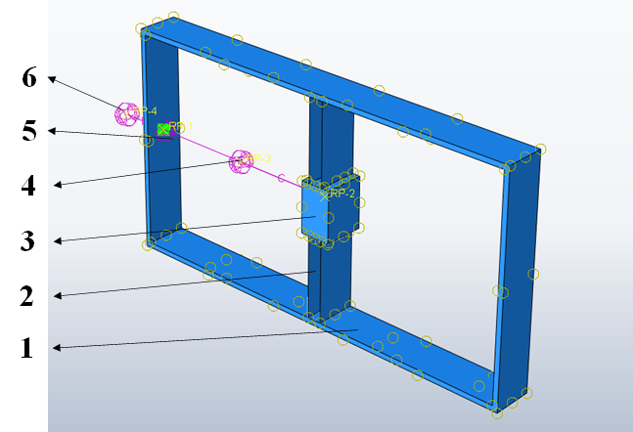

Figure 5: The dynamic vibration system: (1) the rigid frame, (2) the leaf springs, (3) the mass oscillator, (4) the gain, (5) the damper, and (6) the spring.

A Latin Hypercube sampling is completed with 98 runs for parameters ranges shown in Table 3 for which the damping ratio of the system is calculated.

|  |  |  |  |  |  |
| --- | --- | --- | --- | --- | --- |
|  | | *Table 3. A partial parameterized input and corresponding numerical results* | | | |
| Case | Control Parameter | | Calibration Parameter | Design Parameter | Numerical System Response |
| Variable  Unit | Mass  *kg* | | Elastic Modulus  *N/m2* | Gain Factor  *N*s/m* | Damping Ratio  - |
| 1 | 0.9625 | | 54037300000 | 11.5 | 0.0979 |
| 2 | 0.8175 | | 58698200000 | 46.5 | 0.217 |
| 3 | 0.9525 | | 72098300000 | 76.5 | 0.268 |
| 4 | 0.7275 | | 70350500000 | 80.5 | 0.3496 |
| 5 | 1.0125 | | 71515700000 | 73.5 | 0.2483 |
| 6 | 1.0875 | | 64233000000 | 10.5 | 0.0815 |
| … | … | | … | … | … |
| 93 | 1.0575 | | 72389600000 | 54.5 | 0.1855 |
| 94 | 0.8775 | | 68311300000 | 91.5 | 0.3621 |
| 95 | 0.7675 | | 56950400000 | 19.5 | 0.1326 |
| 96 | 0.7525 | | 71807000000 | 83.5 | 0.3489 |
| 97 | 0.8125 | | 68893900000 | 27.5 | 0.1392 |
| 98 | 1.0525 | | 48793800000 | 34.5 | 0.1679 |